Protection mode :
Protection type : II 2G Ex eb IIC T6 Gb IP23 / IP66
II 2G Ex eb mb IIC T6 Gb IP66
II 2D Ex tb IIIC T85°C Db IP66
I M2 Ex eb mb I 150°C Mb IP66
Class of temperature : T6
Ambient temperature : -20 / +50°C
Zones : 1 – 2 – 21 – 22 – M2

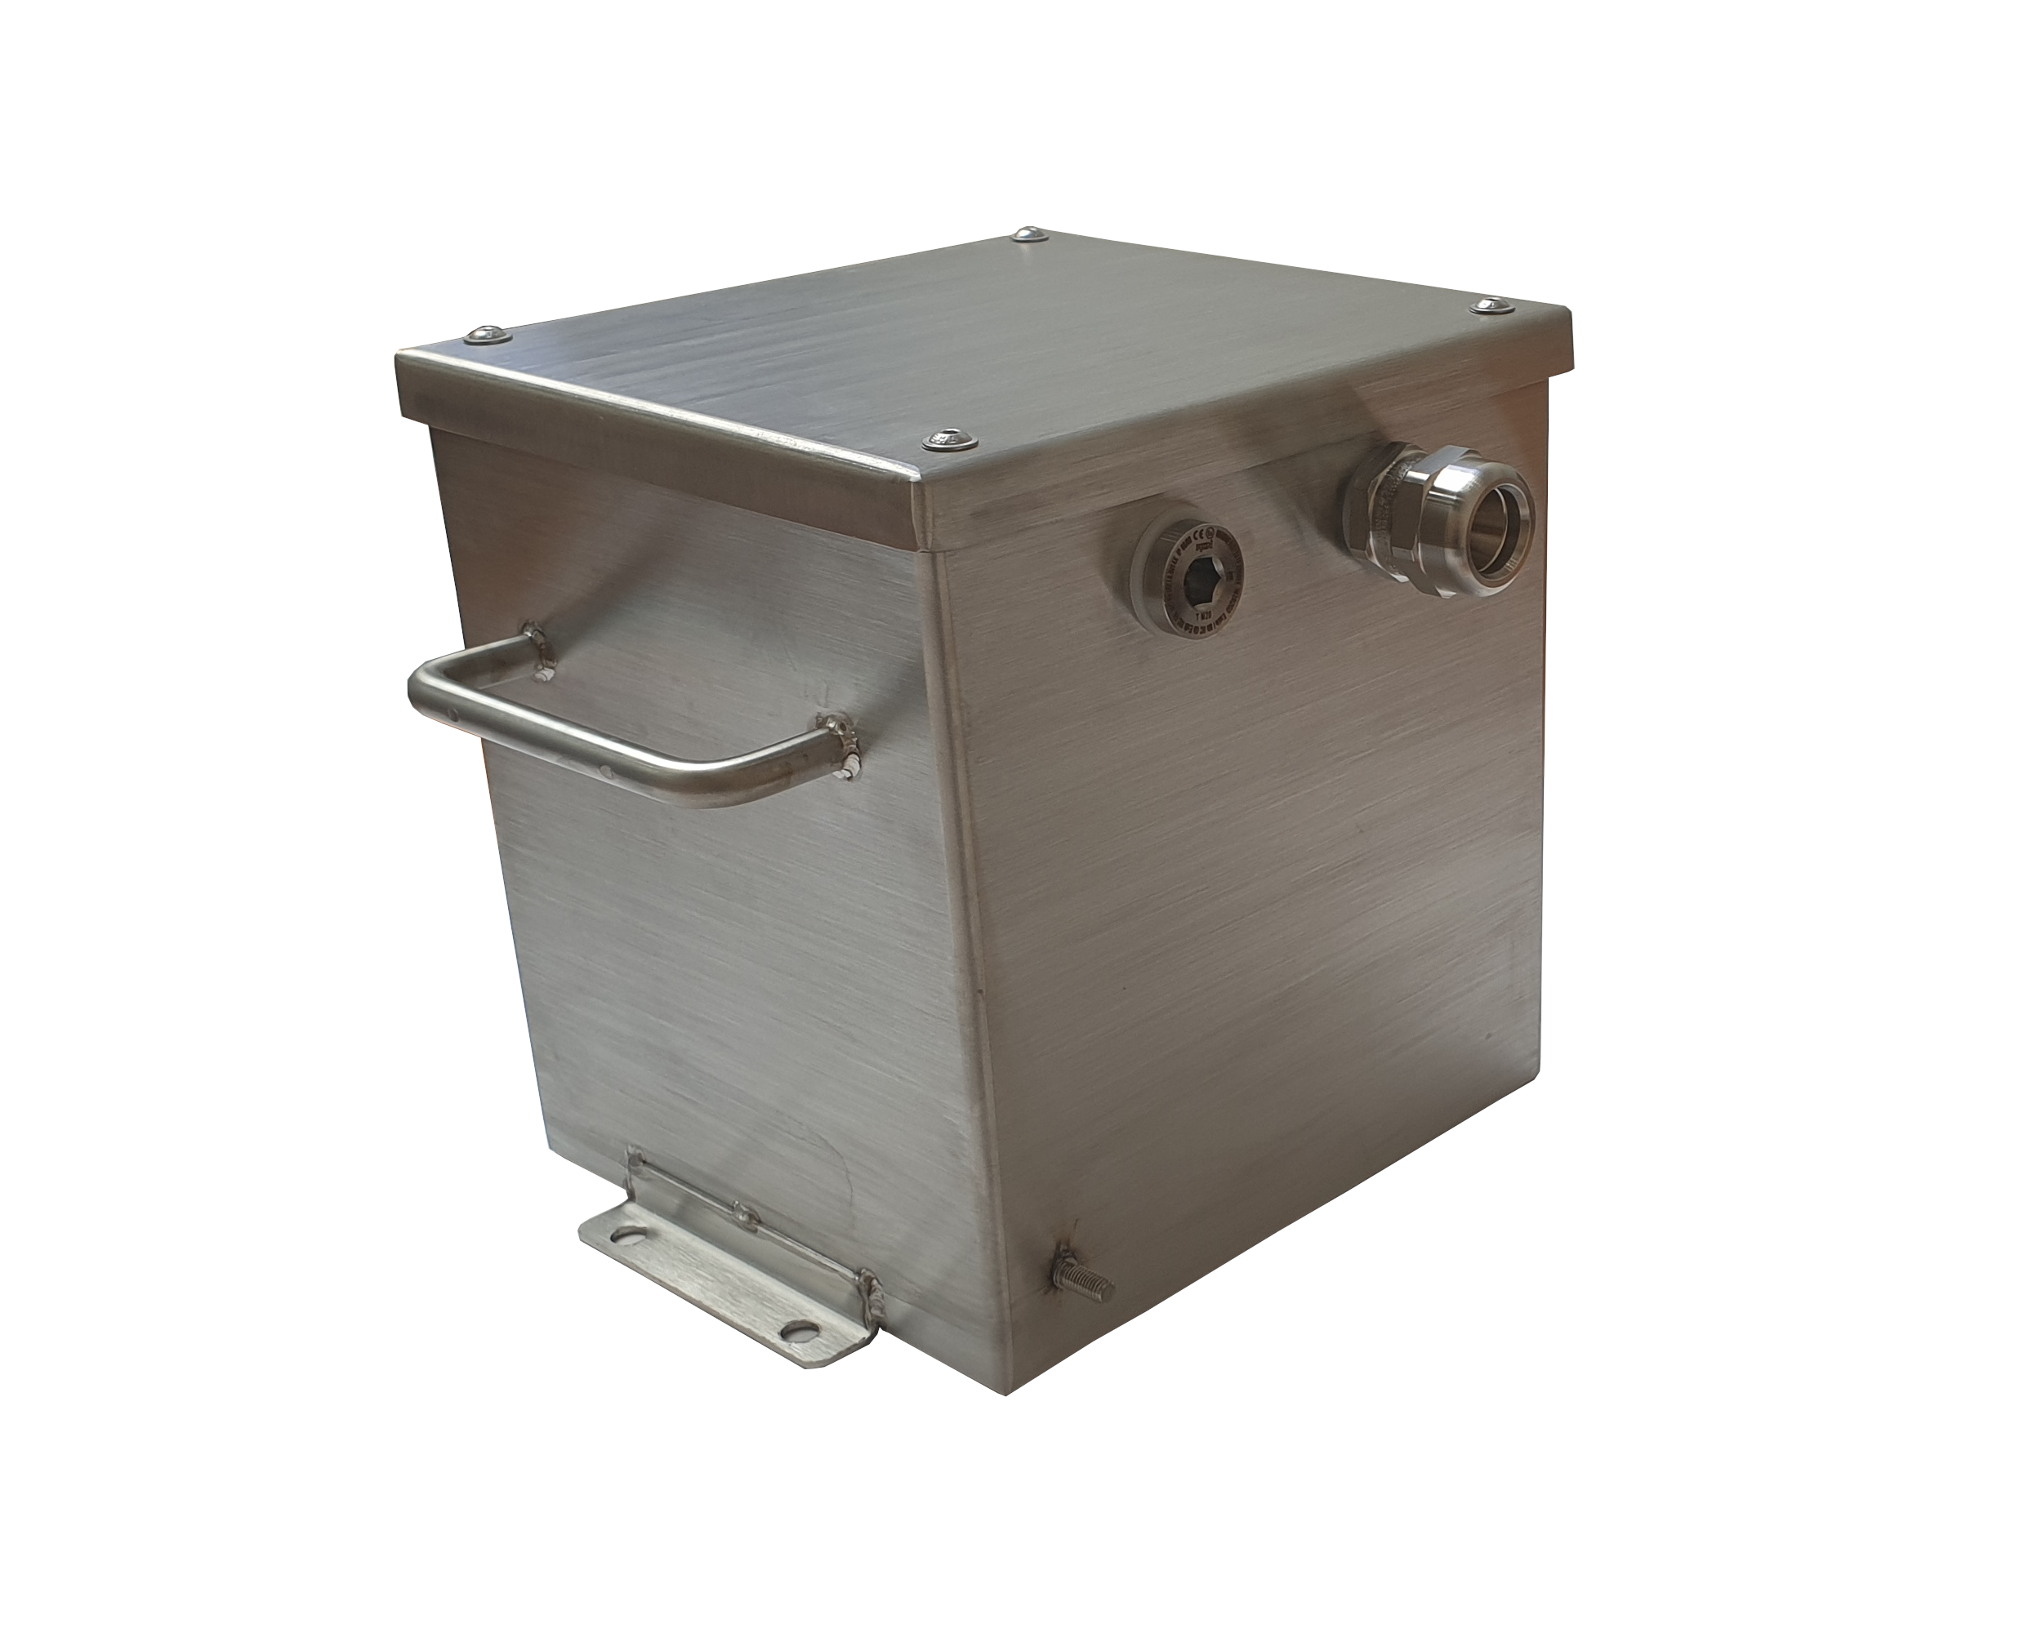

Description :
Battery box including two FIAMM batteries FG20803 of 12V 18Ah. This battery is designed to respond to more or less long discharge regimes.
Design of the AISI 316L stainless steel box with screwed lid on the underside.
Supplied with cable gland and cable.

Nominal voltage : 12 Volt
Nominal capacity : 18 Ah C20 sous 1.75 Vpc à 25 °C
Floating charging voltage : 13.50 - 13.80 V à 25 °C
Boost charge voltage : 14.40 - 15.00 V à 25 °C
Float voltage compensation : -18mV/°C
Maximum charging current : 4.5 A
Weight : 5.9 kg
Battery dimension L x W x (TH) : 181 x 76 x 167
Storage : Batteries lose part of their capacity during storage, due to self-discharge.
Fiamm recommends a maximum storage of 6 months under 25 ° C beyond this period it will be necessary to recharge the battery.
The longer the storage, the longer the refill will be. Fiamm recommends the following method: 2.4V / battery for a maximum duration of 24 hours at 20 ° C

Technical specifications :

Dimensions : Diagram for illustrative purposes these dimensions may change
Matériaux :
Corps et couvercle: alliage d’aluminium.
Vis: acier inoxydable.
Graisse de silicone IP 66.
Sur demande:
Joint d’étanchéité en néoprène (IP 67).
Charnières en acier zingué ou inoxydable.
Plaque de fond en acier zingué.
Boutons poussoirs, voyants, sélecteurs.
Soupape de purge/drainage.
Autres couleurs de peinture.
Traitement anti-corrosif pour brume saline.
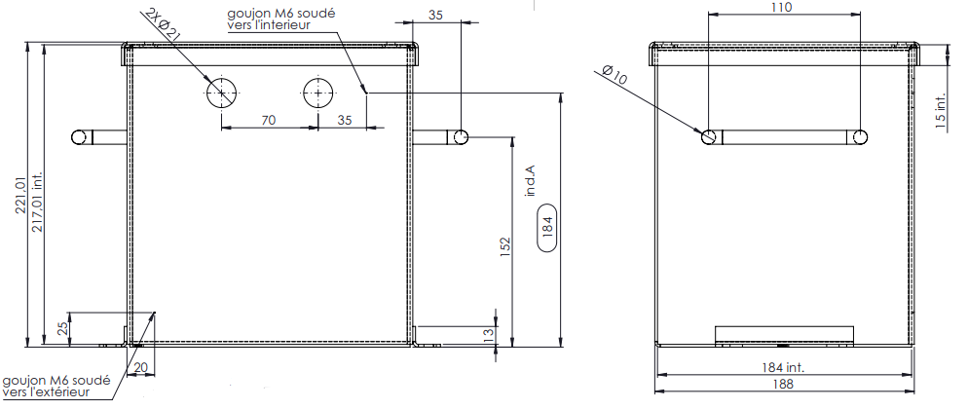
Capacity loss during storage at various temperatures :
*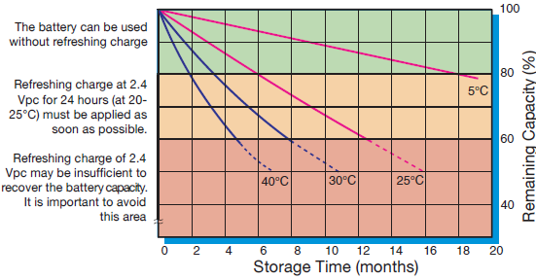
Battery Voltage and Charge Time for Standby Use (at 25°C) :
Discharge curves at different current / ﬁnal voltage (at 25°C):
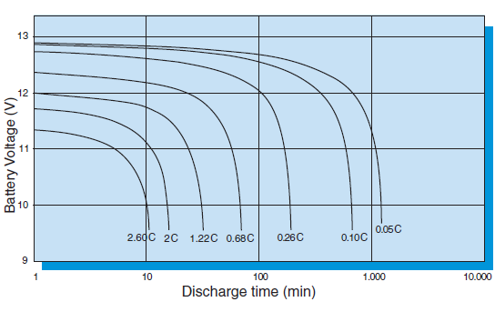

Constant Current discharge table (Amperes) :
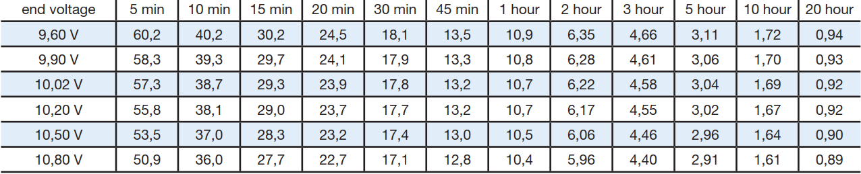
Constant Power discharge table (Watts per bloc) :
